BUG REPORT
Title: Authentication failure on login page with valid credentials - "Your email, password, IP address or location did not match"
Environment: Production (app.vwo.com)
Severity: Critical (Authentication Bypass/Blocker)
Priority: High
Steps to Reproduce:
- 1. Navigate to https://app.vwo.com/
- 2. Enter valid Email ID: sample1234 in the input field.
- 3. Enter the correct Password: Sample@1234 associated with the account.
- 4. Click on the "Sign in" button.
Expected Result: User should be successfully authenticated and redirected to the VWO Dashboard.
Actual Result: Authentication fails and a generic error message is displayed: "Your email, password, IP address or location did not match."
Evidence:
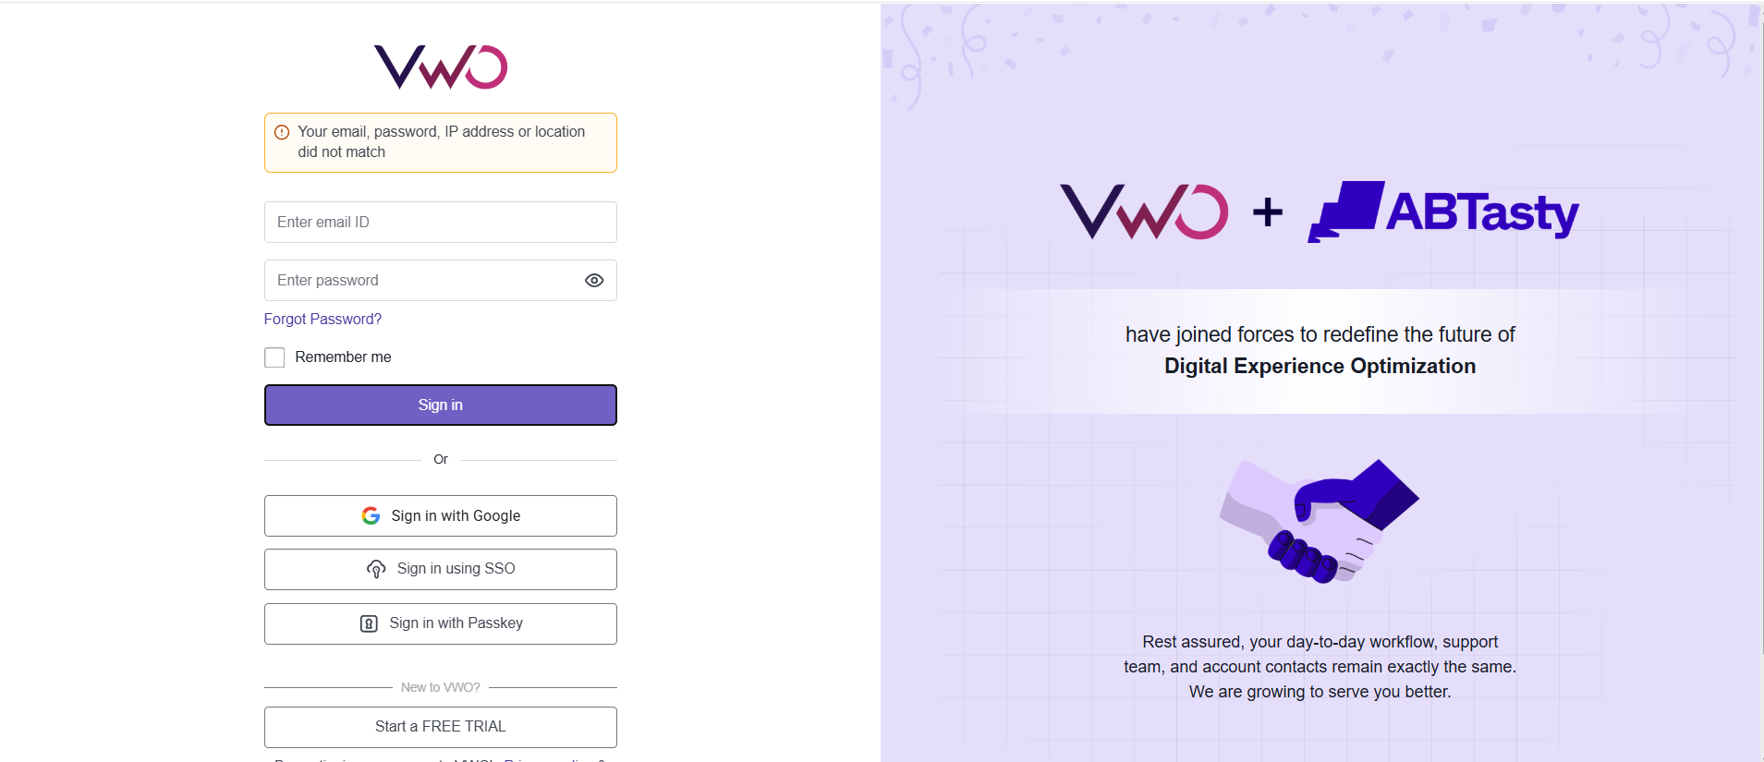
--- End of Bug Report ---

